General Overview:
The purpose of the build-out line is to
- Allow goalkeepers and their teammates more time to control the ball before being pressured from opposing players so teams can 'build play from the back’;
- Eliminate the constant punting from goalkeepers and the heading from punts;
- Teach goalkeepers proper distribution techniques in throwing and rolling the ball;
- Allowing “whole team” attacking (where the defensive line are the start of an attack);
- Teach roles and responsibilities to opposing team for cover and balance in getting ready for an attack.
The build-out line will be used at the U8/U10 ages. For player safety, goalkeepers are no longer permitted to punt or drop kick the ball. Goalies can pass on the ground, throw, or roll the ball.
Coaches (NOT OFFICIALS) should address players who are slow to retreat, or the referee can issue misconduct, if necessary.
Benefits:
- Players will have more touches on the ball.
- Players will learn the objectives and the principles of play for each third of the field.
- Passing is promoted more.
- Playing the ball out of the back is done in a less pressured way.
- Young players will be able to see visually where their position is on the field.
- Players will play more as a team than as individuals.
Field Markings:
- For U8: The build-out line is drawn, using either dashed lines or paint of a different color, on the field parallel to the goal line. The line will be halfway between the penalty area and the midfield line.
- For U10: The build-out line will be parallel to the goal line at the “bottom” of the center circle. At the start of the season, these lines will be drawn, using either dashed lines or paint of a different color, for player recognition and be allowed to fade to be replaced with cones placed 1 yard outside of the field.
U8: 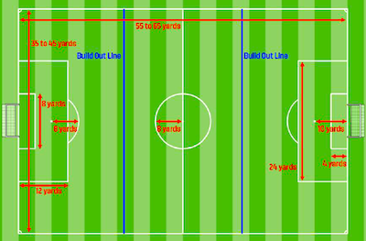 U10: 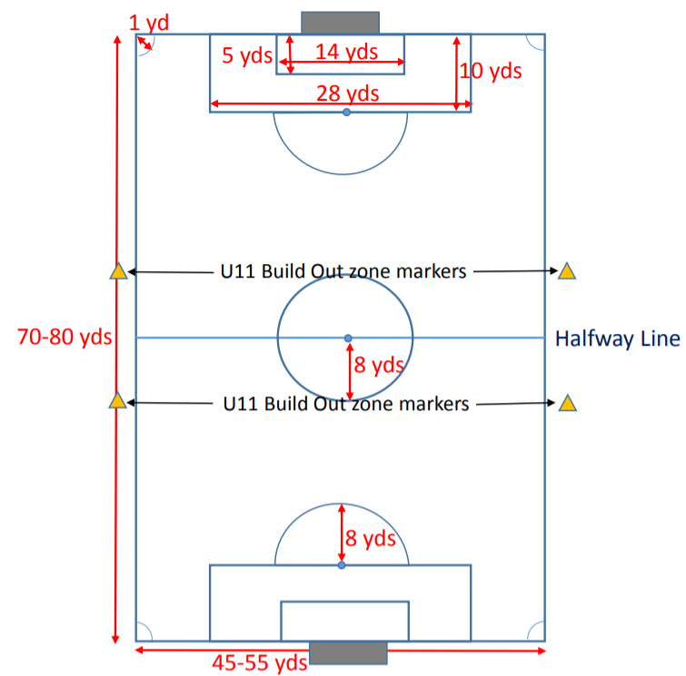

Use of:
There are two situations when the build out lines are to be used for U8/U10 players to “Drop Off” in order to “build out of the back”: Goal Kicks and Goalkeeper Possessions. The build out lines may also be used for Offsides Fouls for the U8 level.
BUILD-OUT LINE RULE 1 = GOAL KICKS:
At all goal kicks, opposing players must move out of the build-out area. Opposing players must remain on the other side of the build-out line until the ball is in play. The ball is in play once the ball leaves the penalty area. The sanction is to retake the goal kick. The ball is not required to clear the build-out area to be in play. The build-out line is not relevant for any restart other than goal kicks.
BUILD-OUT LINE RULE 2 = GOALKEEPER POSSESSION:
At all goalkeeper possessions, opposing players must move behind the build-out line. Goalkeeper possession includes the goalkeeper contacting the ball with any part of their hand or arm including bouncing and tossing/catching the ball. Opposing players must remain outside of the build-out area until the goalkeeper releases ball from their hands. The sanction is an IFK (Indirect Free Kick) to the goalkeeper’s team where the build-out line infringement occurred. The six-second goalkeeper possession rule is not enforced until all opposing players are outside of the build out area.

If the goalkeeper punts or drop-kicks the ball, an IFK for the opposing team at the point of infraction or on the goal line parallel to the net, if the infraction happened inside the Goal Area.

Goalkeeper may put the ball into play before opponents have retreated behind the build out line. The release will resume normal play for all players.
OFFSIDES FOR U8: (not for our league, but information outside of our league)
An U8 player will not be deemed in an offside position until they cross the BUILD OUT LINE to place themselves between that line and the goal line. In other words, the offside rules move from the Midfield Line to the Build Out Line. Players are still not offsides on their own half or if they receive the ball from an opponent.
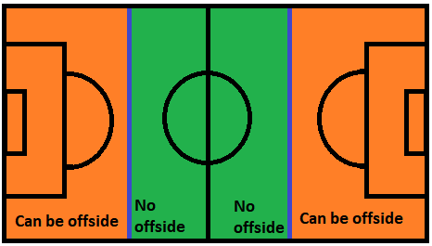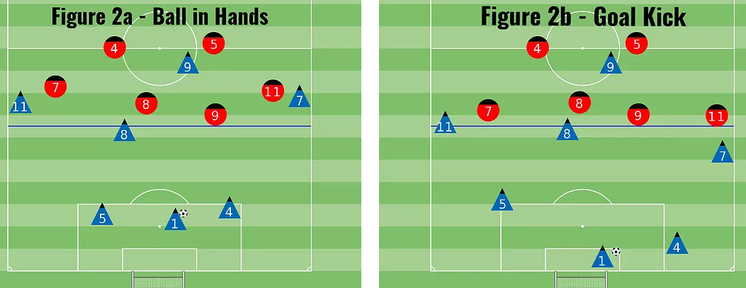
Possible set-up situations for Rule 1 and 2
BUILD-OUT LINE RULE 1 FAQs:
- Can the goalkeeper throw or roll a goal kick?
No. At a goal kick the ball must be stationary inside the goal area. The ball must be kicked and the ball is not in play until the ball leaves the penalty area.
- For indirect free kicks or direct free kicks that occur inside a team's own build out line area does the opposing team have to be outside of the build out line area or just 10 yards away?
For all restarts, other than goal kicks, the build-out area is not relevant and the normal minimum required distance would apply.
- For throw-ins that occur inside a team's own build out line area does the opposing team have to be outside of the build out line area or just 6 feet (2 yards) away?
For all restarts, other than goal kicks, the build-out area is not relevant and the normal minimum required distance would apply.
BUILD-OUT LINE 2 FAQs:
- Can the goalie place the ball on the ground and kick it to anywhere in the field?
Yes. However, once the goalkeeper releases the ball from their hands, opposing players who have cleared the build-out area, may enter the build-out area and play as normal including pressuring/challenging for the ball.
- What’s the call on defenders crossing the build out line too soon?
The ref can delay the goalkeeper to back up the defenders to the correct side of the line. If persistent, misconduct can be issued.
- If the ball has to leave the penalty area to “be in play” can the goalie put the ball on the ground and dribble around for an indefinite period of time?
The ball does not need to leave the penalty area to be in play. The ball has always been in play. The goalkeeper may put the ball on the ground and dribble or pass or kick the ball at any time. Once the goalkeeper releases the ball from their hands, opposing players who have cleared the build-out line may enter the build out area (including the penalty area) and play as normal.
- They are not holding the ball in their hands anymore, so does the 6 second rule apply?
The six-second rule only applies to the goalkeeper controlling the ball in their hands; however, the six-second rule does not begin until all opposing players have moved outside of the build-out area.
- Can the keeper play the ball early, or must they wait for the other team to retreat behind the dash line?
Yes, the keeper can play the ball early, but there can be no penalty to the defending team for not allowing them time to retreat behind the dash line.
- If goalie kicks the ball past the buildout line before it is played by his/her team is that a foul, and what is the restart?
That scenario is not an infraction. The ball does not need to be 'played' by a teammate inside the build-out area. The goalkeeper kicking the ball is fine although punting is not permitted. The build-out line has nothing to do with when the ball is in play, it is only used temporarily to allow defenders (including the goalkeeper) a bit more time to play the ball without pressure to learn to 'build play from the back.'
- Does “every part of the defender’s body” have to be behind the line?
There are no restrictions regarding defenders on the field. All attackers must fully clear and remain outside the build-out area until the goalkeeper releases the ball. Any opposing player(s) inside the build-out area cannot interfere with play until leaving the build-out area and the goalkeeper releases the ball from their hands. This includes a scenario where an opposing player, outside the build-out area, wins the ball and plays the ball to a teammate inside the build-out area but, who did not clear the build-out area, (indirect free kick to the defending team.)
- The goalkeeper cannot punt off a save?
Correct. Punting includes dropkicks, bouncing the ball off of the ground and/or tossing the ball into the air to kick it. The sanction is an Indirect Free Kick to the opposing team where the goalkeeper punted the ball subject to special circumstances for free kicks within a goal area.
- Once GK possesses the ball, the opposing team must move beyond the build out line and the GK can then distribute the ball to his/her players behind or in front of the build out line -once a teammate of the GK receives the ball behind the build out line, then the opposing team may challenge for the ball or do they need to wait until the team with possession moves outside of the build out line?
In this situation the ball has always been in play. Opposing players are only restricted because of the goalkeeper possession. Opposing players may enter the build-out area as soon as the goalkeeper releases the ball from their hands. A ‘second touch’ is not required for opposing players to enter the build-out area.
- If the GK distributes the ball in front of the build out line (without punting it), the opposing team may immediately challenge for the ball?
The goalkeeper may distribute the ball by dribbling, throwing, rolling or kicking the ball. If the goalkeeper distributes the ball out of the build-out area, opposing players may pressure the ball.
Note: However, if an opposing player, outside the build-out area, wins the ball and then plays the ball to a teammate inside the build-out area, who did not clear the build-out area, the sanction is an indirect free kick to the defending team only if that player is in an offsides position.
A few helpful videos on Build Out Lines:
Build Out Line Rules
https://www.youtube.com/watch?v=PAE4d0wLmhc
Explaining the Build Out Line 7v7
https://www.youtube.com/watch?v=sQ92KfiIwok
7v7 Build Out Line Part II
https://www.youtube.com/watch?v=aJovFMAZilo

Guidance to Referees
Encourage the opponents to move quickly beyond the build-out line. Do not start the “6-sec clock” until all opponents have retreated behind the build-out line.
The referee should position themselves on or very close to the build-out line and ask the players to stay behind until the ball is released.
If a player insists on crossing over the line a couple of times without respecting the referee’s direction, you have an IFK for the goalkeeper’s team… location: on the build-out line, place closest to where the player crossed the line

Quick Reference Chart:

